TASK 9:
class Solution {
public void moveZeroes(int[] nums) {
int pos = 0; // index to place next non-zero element

// First pass: move all non-zero elements to the front
for (int i = 0; i < nums.length; i++) {
if (nums[i] != 0) {
nums[pos] = nums[i];
pos++;
}
}

// Second pass: fill the rest with zeros
while (pos < nums.length) {
nums[pos] = 0;
pos++;
}
}
}

Case 1:
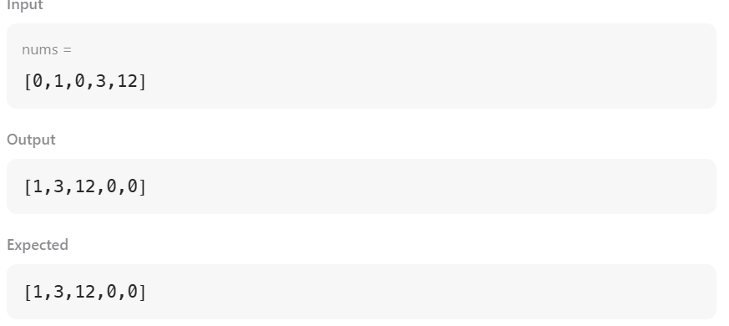
Case 2:
